**Socio-Economic Factor Affecting Attitude of Local and Cultural and Eco-Tourism Development in Central Province in Sri Lanka**

**Munasinghe S. B. M. O. K.[1]** Gianotten Printed Media - Grafisch Woordenboek - enveloppen snit  **and Jayawardana S. M. M. S.[2]**

**Abstract**

Video provides a powerful way to help you prove your point. When you click Online Video, you can paste in the embed code for the video you want to add. You can also type a keyword to search online for the video that best fits your document. To make your document look professionally produced, Word provides header, footer, cover page, and text box designs that complement each other. For example, you can add a matching cover page, header, and sidebar. Click Insert and then choose the elements you want from the different galleries. Themes and styles also help keep your document coordinated. When you click Design and choose a new Theme, the pictures, charts, and SmartArt graphics change to match your new theme. When you apply styles, your headings change to match the new theme. Save time in Word with new buttons that show up where you need them. You can also type a keyword to search online for the video that best fits your document. To make your document look professionally produced, Word provides header, footer, cover page, and text box designs that complement each other. For example, you can add a matching cover page, header, and sidebar. Click Insert and then choose the elements you want from the different galleries. Themes and styles also help keep your document coordinated. When you click Design and choose a new Theme, the pictures, charts, and SmartArt graphics change to match your new theme. When you apply styles, your headings change to match the new theme. Reading is easier, too, in the new Reading view. You can collapse parts of the document and focus on the text you want. If you need to stop reading before you reach the end, Word remembers where you left off - even on another device. box designs that complement each other. For example, you can add a matching cover page, header, and sidebar your document coordinated. When you click Design and choose a new Theme, the pictures, charts, and SmartArt graphics change to match your new theme. When you apply styles, your headings change to match the new theme. Reading is easier, too, in the new Reading view. You can collapse parts of the document and focus on the text you want. If you need to stop the pictures, charts, and SmartArt graphics change to match your new theme. When you apply styles, your headings change to match the new theme. Reading is easier, too, in the new Reading view. You can collapse parts of the document and focus on the text you want. If you need to stop the pictures, charts, and SmartArt graphics change to match your new theme. When you apply styles, your headings change to match the new theme. Reading is easier, too, in the new Reading

***Keywords:*** *Central Province, Cultural and eco-tourism, Social exchange theory*

1. Department of Information and Communication Technology, Faculty of Technology, Rajarata University of Sri Lanka, Sri Lanka. 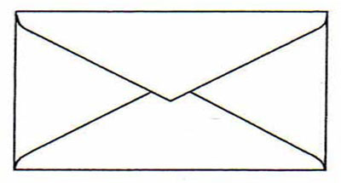Corresponding Author: look4madhawa@gmail.com
2. Department of Information and Communication Technology, Faculty of Applied Sciences, Rajarata University of Sri Lanka, Sri Lanka